**Experiment no. 2**

**Write an Embedded C program to add array of n numbers.**

**Algorithm :**

1. Initialize counter to number of array elements.

2. Initialize pointer to the first element of an array.

3. Initialization of accumulated sum.

4. Addition of an elements to accumulated sum.

5. After each addition check whether carry is generated, if yes then increment carry counter

by one.

6. Increment memory pointer by one to point to the next element.

7. Decrement count with each addition.

8. Go on adding numbers in internal memory till counter becomes zero. If not then go to step 4.

**Flowchart :**

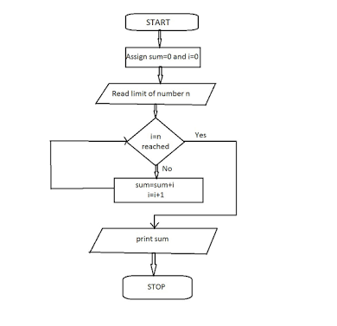

**/* Program for Addition of Array. */**

#include <stdio.h>

#include <stdlib.h>

#include <pic18f4550.h>

void main(void) {

int i,sum,n;

int number[] = {1,2,3,4,5,6,7,8,9,10}; // array of 10 numbers

sum = 0; // initialize sum as zero

for(i=0; i<=9;i++){ //indexing start from 0 to 9

sum = sum+number[i];

}

TRISB =0; //initialize Port_B as output

PORTB = sum; // from sum to PORT_B

}